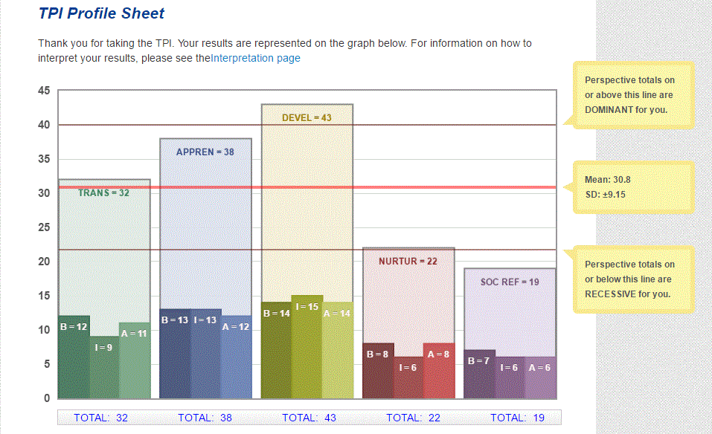

**Guidance on Writing a Philosophy of Teaching Statement**

<http://ucat.osu.edu/professional-development/teaching-portfolio/philosophy/guidance/>

Chism’s five components of a teaching statement

In her article (Chism, 1998), “Developing a Philosophy of Teaching Statement,” Nancy Chism, former Director of Faculty & TA Development at The Ohio State University, suggests five major components.

**1. Conceptualization of learning**Ask yourself such questions as “What do we mean by learning?” and “What happens in a learning situation?” Think of your answers to these questions based on your personal experience. Chism points out that some teachers have tried to express and explain their understanding of learning through the use of metaphor, because drawing comparisons with known entities can stimulate thinking, whether or not the metaphor is actually used in the statement. On the other hand, most instructors tend to take a more direct approach in conceptualizing learning, i.e., to describe what they think occurs during a learning episode, based on their observation and experience or based on current literature on teaching and learning.

**2. Conceptualization of teaching**Ask yourself questions such as “What do we mean by teaching?” and “How do I facilitate this process as a teacher?” Chism suggests that personal teaching beliefs on how the instructor facilitates the learning process would be appropriate for this section. Again, the metaphor format can be used, but a common practice is a more direct description of the nature of a teacher with respect to motivating and facilitating learning. Along with the questions above, you may also address such issues as how to challenge students intellectually and support them academically and how the teacher can respond to different learning styles, help students who are frustrated, and accommodate different abilities. Furthermore, you may talk about how you as a teacher have come to these conclusions (e.g., through past experience as a student or teacher, or as a result of literature reading or taking classes).

**3. Goals for students**This section should entail the description of what skills the teacher expects her/his students to obtain as the result of learning. You may address such issues as what goals you set for your classes, what the rationale behind them is, what kind of activities you try to implement in class in order to reach these goals, and how the goals have changed over time as you learn more about teaching and learning. For instance, you can describe how you have expected students to learn not only the content, but also skills such as critical thinking, writing, and problem solving, followed by elaboration on how you have designed/planned individual sessions towards accomplishing the goals.

**4. Implementation of the philosophy**An important component of the statement of a teaching philosophy should be the illustration of how one’s concepts about teaching and learning and goals for students are transformed into classroom activities. Ask yourself, “How do I operationalize my philosophy of teaching in the classroom?” and “What personal characteristics in myself or my students influence the way in which I approach teaching?” To answer these questions, you may reflect on how you present yourself and course materials, what activities, assignments, and projects you implement in the teaching-learning process, how you interact with students in and outside class, and the consequences.

**5. Professional growth plan**It is important for teachers to continue professional growth, and to do so, teachers need to set clear goals and means to accomplish these goals. Think about questions such as “What goals have I set for myself as a teacher?” and “How do I accomplish these goals?” You can elaborate this plan in your statement of teaching philosophy. For instance, you can illustrate how you have professionally grown over the years, what challenges exist at the present, what long-term development goals you have projected, and what you will do to reach these goals. Chism suggests that writing this section can help you think about how your perspectives and actions have changed over time.

In summary, these are the main questions Chism suggests to answer in a statement:

* How do people learn?
* How do I facilitate that learning?
* What goals do I have for my students?
* Why do I teach the way that I do?
* What do I do to implement these ideas about teaching and learning in the classroom?
* Are these things working? Do my student meet the goals?
* How do I know they are working?
* What are my future goals for growth as a teacher?

Goodyear and Allchin’s suggestions about necessary components

Gail Goodyear and Douglas Allchin (1998) have made suggestions for structuring the statement of teaching philosophy in a somewhat different way than Chism.

**1. Integration of responsibilities.** Teaching, research, and public service are the main missions of university faculty. Each teacher therefore should explicitly describe what they do in carrying out these three missions in their statements of teaching philosophy.

**2. Expertise.** It is important for faculty to link their special knowledge or expertise in the field to ways of helping their students learn that knowledge and communicate with students effectively during this teaching-learning process.

**3. Relationships.** A healthy relationship between the teacher and students is “essential to successful teaching.” Ways in which a teacher establishes such a relationship, such as getting to know students, specific ways of building rapport with students, and special teaching techniques used, should be explicitly described in his or her statement of teaching philosophy.

**4. Learning environment.** In conjunction with the previous issue, the authors suggest that teachers can illustrate what they have done to create a supportive learning environment in their classes socially, psychologically, and physically to help students learn.

**5. Methods, strategies, and innovation.** Faculty should use teaching philosophy statements to reflect on their teaching practice, both past and present, as well as to illustrate how special teaching techniques they use are in compliance with their teaching philosophy.

**6. Outcomes.** Teachers can demonstrate in their statements of teaching philosophy how the previous efforts have produced anticipated outcomes. For example, students have learned the subject matter and they are able to use the knowledge learned in class to solve real-world problems.

Reflection tools to help get you started

The Center for Excellence in Teaching and Learning at the University of Texas at El Paso has great resources and tools to get you thinking about your teaching reflectively. On their site, you will find the following exercises designed to help you articulate the various components of your teaching philosophy.

“Who? Me? Recognize your Teaching Philosophy”  
“Elaborate an Exemplar”  
“The Ideal Student”  
“Plumbing Values”

You may also want to start with thinking about your teaching style. There are several teaching style inventories online.

Using metaphors

The use of metaphors can be a helpful tool in describing our concept of the teaching and learning enterprise. There are instructors who are able to write wonderful philosophy statements that use metaphors thematically throughout the document, continually tying the components back to that metaphor. Other use metaphors only in the philosophy development stages, using it as a tool to help them better articulate their ideas, rather than actually writing the metaphor in the final document. Either way, this tool provides your audience with a solid understanding of how you see your role in the teaching/learning process.

Here are some exemplary metaphors of learning (Grasha, 1996):

**Containers:** “Knowledge is viewed as a substance and the instructor is a container filled with content and facts. The student is perceived as a vessel wanting to be filled up.” (p. 35)

**Journey-Guide:** “Knowledge is perceived as a perspective on the horizon. The teacher guides students on their journey. Students need to follow a course, must overcome obstacles and hurdles, …. they will come to the end of their journey.” (p.35)

**Master-Disciple:** “Knowledge is a skill or habit to be learned. The instructor trains students and the students ideally do what they are told without questioning the master.” (p.35)

Other metaphors:

* Coach
* Gardener
* Director of a play
* General leading troops into battle
* Midwife
* Swiss army knife
* Evangelist
* Rabbi
* Entertainer
* Choreographer
* Tour bus driver with passengers who keep their window curtain closed

References

Chism, N. V. N. (1998). Developing a philosophy of teaching statement. *Essays on Teaching Excellence 9* (3), 1-2. Professional and Organizational Development Network in Higher Education.

Grasha, A.F. (1996).*Teaching with style: A practical guide to enhancing learning by understanding teaching and learning styles*. Pittsburgh, PA: Alliance Publishers.

Goodyear, G. E. & Allchin, D. (1998) Statement of teaching philosophy. *To Improve the Academy 17*, 103-22. Stillwater, OK: New Forums Press.

Articulating Your Philosophy of Teaching

<http://cetalweb.utep.edu/sun/CETaL/resources/portfolios/ex-phil.htm>

*Varioius exercises to guide someone in thinking about, articulating, and writing a statement of teaching philosophy*

**Who? Me? Recognize Your Teaching Philosophy**

Feeling like "I don't have a teaching philosophy -- where am I gonna get one?" Everyone acts with an operational teaching philosophy, whether it is explicit or not. For example, the grading policy as stated on a syllabus in a sense defines what you value as the outcome of the course. Think of restating that in a positive sense as the intended "product" of your teaching. Or consider someone who walked into your classroom, office, lab or studio and examined your interaction with students. This reveals your concept of the relationship between teacher and student and what goes on between them--whether it is the delivery of knowledge in a lecture format or honing of analysis skills in a discussion format. What is your role as a teacher, or what should a student expect of you as a teacher?

Lee Shulman and Pat Hutchings from AAHE invite you to diagnose your teaching philosophy and scholarly activity as reflected in your course syllabus. Another good exercise to get started is to identify an episode of good teaching (or learning) and [analyze it fully](http://cetalweb.utep.edu/sun/CETaL/resources/portfolios/writetps.htm#exemplar) to understand your standards for "good" teaching (a reasoned value judgment).

**Elaborating an Exemplar**

Identify one teaching experience that epitomizes what you regard as your best teaching. Explore why. You might also apply this analysis to one or your own most valuable learning experiences.

What might you notice or say about any of the following?:

* teacher-student relationship?
* end-products?
* standards of quality?
* student transformations?
* learning environment?
* attitudes, motivations or other emotions?
* long-term vs. short-term perspectives?
* implicit or explicit values?

**The Ideal Student**

How would you describe the ideal outcome of your teaching in terms of a student's behavior? What should the student know or be able to do?

Note: This exercise might also help you imagine forms of student evaluation or "authentic assessment" that reflect your true goals. Allow your methods to follow your goals.

**Plumbing Values - Moving from "How" to "Why"**

For some teachers, the challenge of developing a statement of teaching philosophy is escaping the prevailing dialogue of teaching methods and how one teaches, and moving into discussion of values and goals. Here are some questions to initiate reflection:

* What is a method of teaching you rely on frequently? Why don't you use another method? Imagine what would happen if you changed. What does this tell you about the outcome of your teaching?
* What do you feel you need to change in how you teach? What difference will this make? Express this in terms of desired outcomes. Re-express this in terms of underlying values.
* What makes you feel good about teaching? What gives you reward? What are the reasons behind the feelings?

**Bibliography**

Chism, Nancy Can Note. "Developing a Philosophy of Teaching Statement." *Essays on Teaching Excellence: Towards the Best in the Academy* 9.3 (1997-98).

Goodyear, Gail and Douglas Allchin. "Statements of Teaching Philosophy." *Towards Improving the Academy* [forthcoming, Fall 1998].

O'Neil. Carol and Alan Wright. 1997. "Reflective Statement on Teaching Philosophy, Practices and Goals." Pp. 33-39 in *Recording Teaching Accomplishment: A Dalhousie Guide to the Teaching Dossier*, 5th ed. Halifax, NS: Dalhousie University Office of Instructional Development and Technology.